Machrihanish Seabird Observatory
Founded September 1993

June Report 2019

Compiled By Eddie Maguire (warden)

Contact the Observatory...
Mobile - 07895 952640
E-mail – msbowarden@gmail.com
Website – www.machrihanishbirdobservatory.org.uk

Photo of the Month....
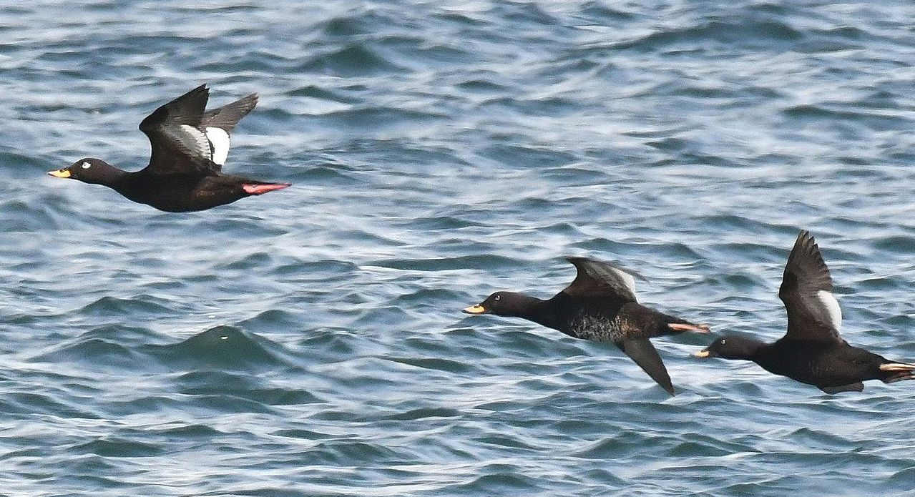

Velvet Scoters – off MSBO 2nd June / all males / adult (left) + 2 immatures

June Report...
Northern Gannets crossing overland in S Kintyre....
Surveillance of Gannets embarking on the 8km / 9 minute flight overland to the west from Campbeltown Harbour to Machrihanish Bay was maintained this month. This unique MSBO Project will continue through to mid-October.

Birding in Argyll?
Find out what rare / scarce birds (many photographed) have been reported in the county recently / visit Argyll Bird Club’s website at www.argyllbirdclub.org (Recent Reports of Scarce & Rare Sightings 2019).

List of Selected Species

Common Shelduck
A b/3 just hatched appeared on 1st followed by b/6 on 16th.
Table 1. Shelduck productivity at Machrihanish during May / June 2016 – 2019.

Year | No. broods | No. ducklings | Mean brood size
2019 | 3 | 19 | 6.3
2018 | 6 | 30 | 6
2017 | 8 | 55 | 6.7
2016 | 6 | 37 | 6.1

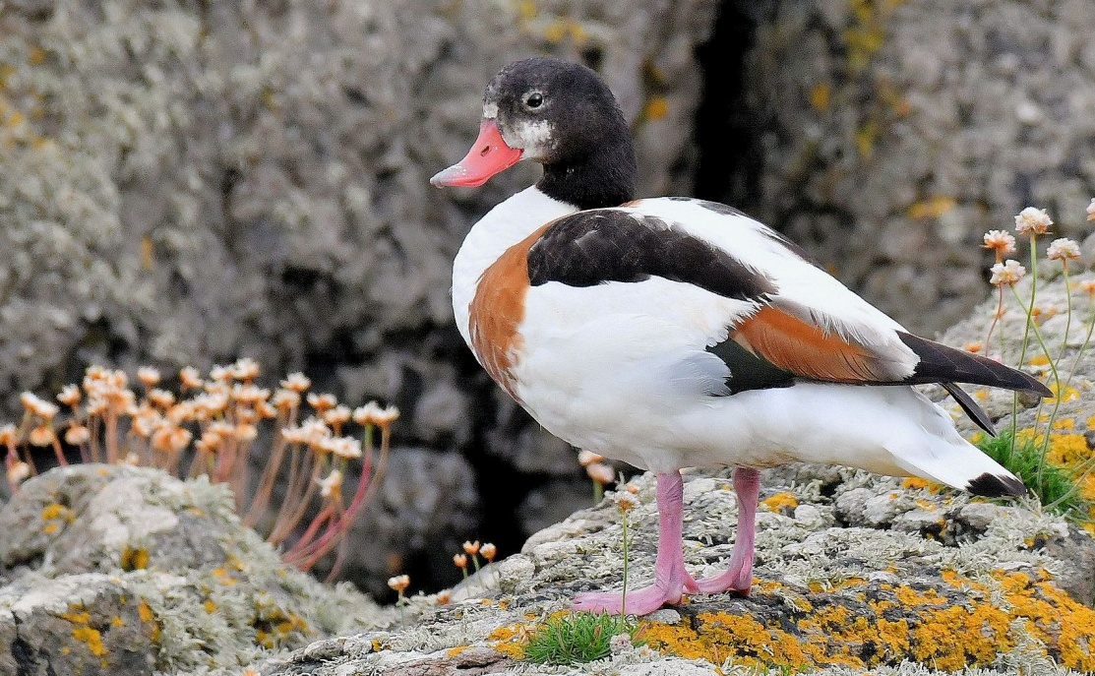
Shelduck – female MSBO 26th June
Mallard
A well-grown b/2 appeared on 2nd.

Velvet Scoter
An exceptional flock of 21 >S off MSBO at 11:25hrs on 2nd June. The birds were well-scattered / small loose groups / at varying distances from the shore (200+m); the total comprised 16 males / 5 females.
This is largest number seen in Argyll since the 1970’s (Eddie Maguire pers. obs. / Birds of Argyll; ap Rheinallt et al 2008).
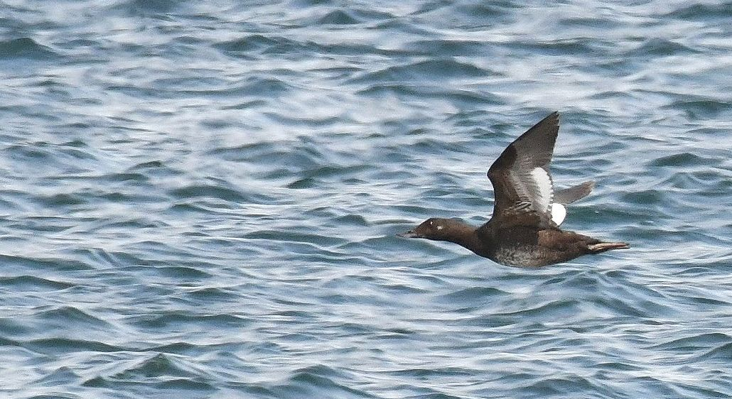
Velvet Scoter – female >S off MSBO 2nd June

Common Scoter
Two males and a female >S on 3rd, 3 males >S on 5th, a male >N on 25th and 25 males >S on 30th.

Common Eider
The first broods just hatched - b/4 & b/3 - appeared on 2nd. This was followed by b/1 and b/5 on 6th, b/4 on 14th and b/1 on 26th.

Table 2
Common Eider productivity at Machrihanish during May / June 2016 – 2019.

Year | No. broods | No. ducklings | Mean brood size
2019 | 6 | 18 | 3
2018 | 8 | 25 | 3.1
2017 | 6 | 23 | 3.8
2016 | 10 | 35 | 3.5

Northern Gannet
A total of 672 >S / 1hr from 09:00hrs on 3rd – the best movement this year.
MSBO Northern Gannet Project...
During June a total of 181 adults crossed 8km overland in S Kintyre on 25 / 30 days of observation.
Table 3. Date / number of adult Gannets crossing 8km overland to the west from Clyde waters (Campbeltown harbour) to the Atlantic (Machrihanish Bay) during June 2019 along with wind direction / force and departure times of first / last bird.

Date  June 2019 | Number  Adults  crossing  overland | Wind  Direction  &  force | Campbeltown  Departure  times of  first / last  bird >W
1st | 5 | SW 2 - 3 | 16:09 – 16:12
2nd | 11 | SSW 3 | 14:15 – 19:45
3rd | 8 | SW 3 - 4 | 12:23 – 20:38
4th | 2 | WNW 1 | 08:05 – 16:00
5th | 6 | N 2 | 15:23 – 18:21
7th | 2 | E 1 | 19:15 – 20:3022
8th | 9 | SW 2 | 19:01 – 20:55
9th | 1 | Variable 2 | 20:44
10th | 2 | W 2 | 15:42 – 16:22
11th | 7 | N 2 | 14:41 – 19:05
15th | 6 | SW 2 -3 | 18:58 – 20:34
16th | 4 | SSW 2 -3 | 13:31 – 15:44
17th | 6 | SSW 4 | 12:08 – 20:30
18th | 1 | S 3 | 18:36
19th | 1 | SW 2 | 19:57
20th | 5 | W 3 | 12:42 – 19:40
21st | 6 | W 3 | 19:04 – 19:25
22nd | 11 | S 2 - 3 | 16:43 – 21:50
23rd | 11 | S 3 | 12:24 – 19:22
24th | 2 | E 2 - 3 | 19:55 – 20:29
25th | 9 | Calm | 11:46 – 18:46
26th | 6 | W 2 | 11:59 – 20:15
28th | 10 | E 3 | 16:01 – 21:27
29th | 18 | WSW 1 | 13:40 – 21:12
30th | 32 | W 2 – 3 | 12:08 – 20:49
Total | 181
April – June  Total | 456

From April to June 2019 a total of 456 adult Northern Gannets embarked on this 8km / 9 minute flight overland on 69 / 91 days of surveillance (Charlie Robertson / MSBO Northern Gannet Project Coordinator).

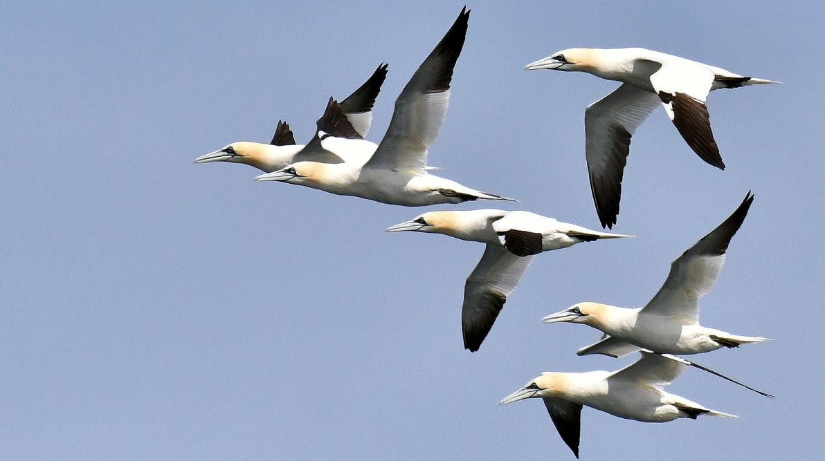
Northern Gannets – a squadron of adults >S off MSBO 30th June

Table 4. The numbers of adult Gannets crossing west over Kintyre during March to October 2017 / 2018 along with the most recent 2019 monthly data.
2017 | March | April | May | June | July | Aug | Sept | Oct
Monthly totals | 2 | 23 | 131 | 126 | 274 | 408 | 491 | 6
Cumulative totals | 2 | 25 | 156 | 282 | 556 | 964 | 1,455 | 1,461
No. days of  Observation | 27 | 29 | 22 | 24 | 31 | 24 | 30 | 20
2018 | March | April | May | June | July | Aug | Sept | Oct
Monthly totals | 6 | 45 | 78 | 336 | 121 | 247 | 372 | 16
Cumulative totals | 6 | 51 | 129 | 465 | 586 | 833 | 1,205 | 1,221
No. days of  Observation | 31 | 30 | 31 | 30 | 31 | 31 | 30 | 25
2019 | March | April | May | June | July | Aug | Sept | Oct
Monthly totals | 0 | 61 | 214 | 181
Cumulative totals | 0 | 61 | 275 | 456
No. days of  Observation | 31 | 30 | 31 | 30
Red-throated Diver
An adult in breeding plumage >S on 20th.

Great Northern Diver
Glenbarr; one in breeding plumage off Killegruer Caravan Park on 5th (Pip Ashley pers. comm.).
MSBO; one partly in breeding plumage on 14th.

Grey Heron
Breeding; 2 pairs nested Lossit Estate (conifer) and at least one pair nested by Kilkerran Road, Campbeltown (conifer).

Common Buzzard
Breeding; unusual nest site with at least one chick on building at Machrihanish Airbase (David Millward / Jo Goudie pers. comm.).

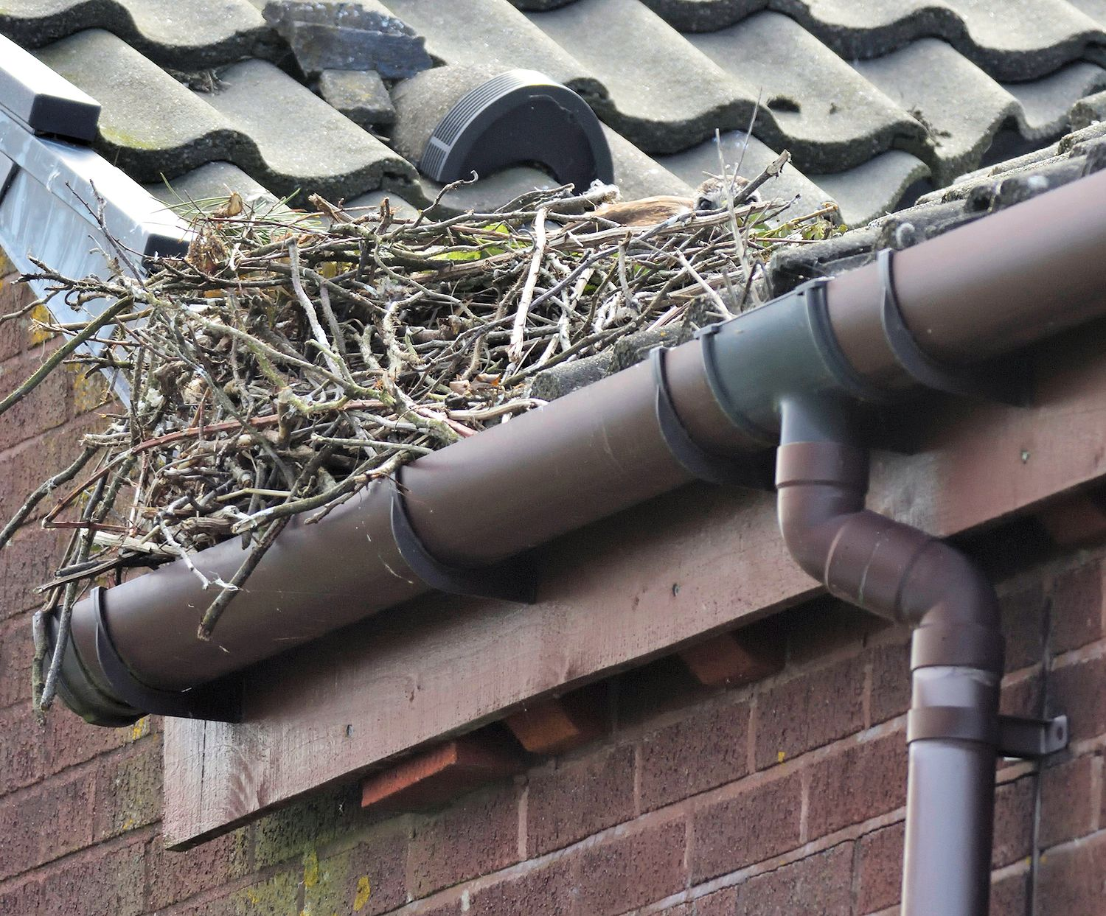
Common Buzzard – nest and chick / photo Jo Goudie
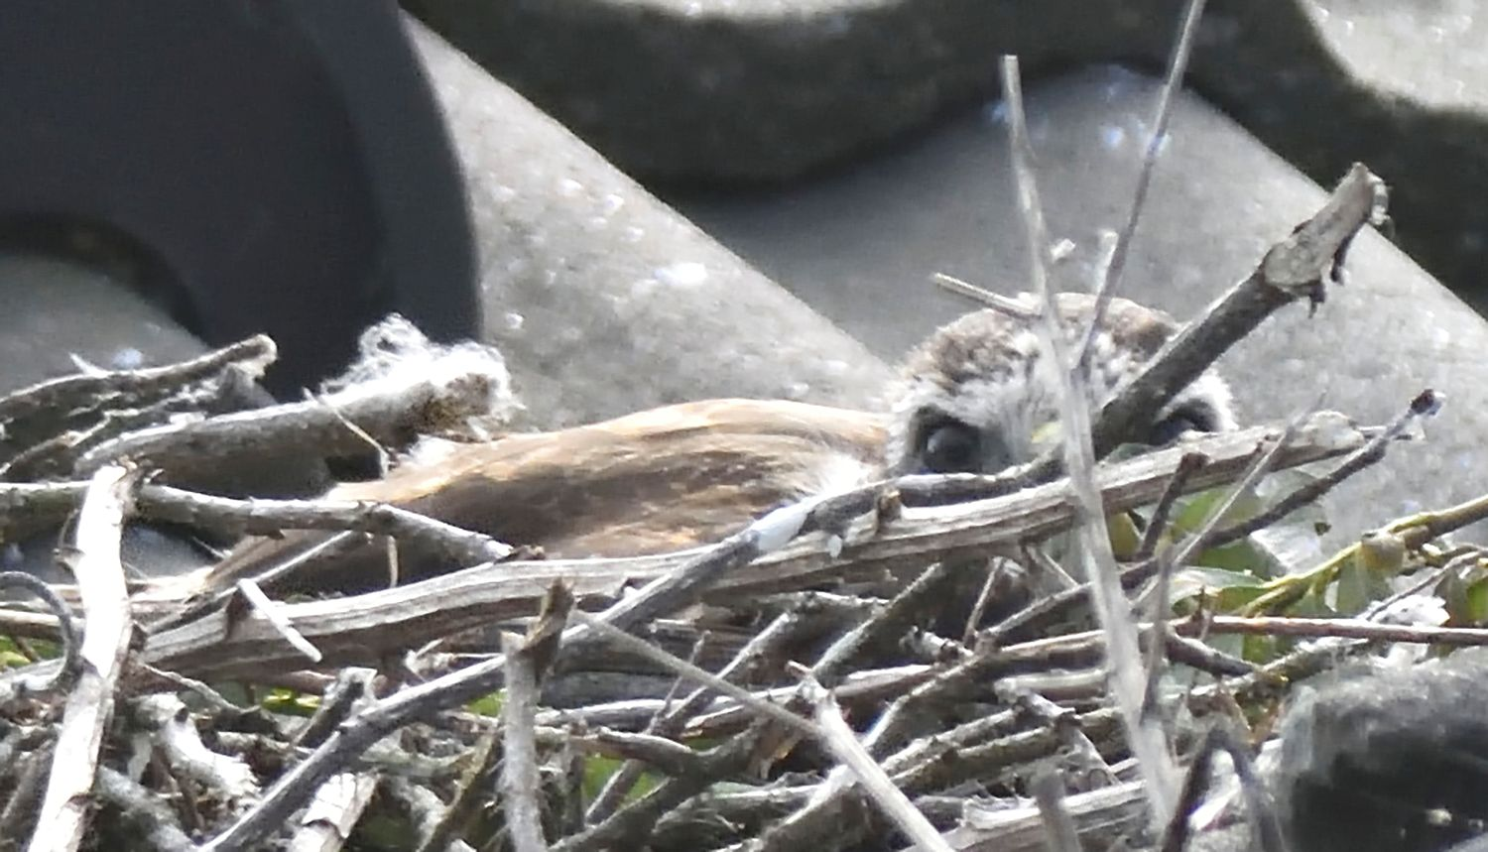
Common Buzzard – nest and large chick / photo Jo Goudie

Peregrine Falcon
An adult attempted to catch a Ruddy Turnstone on 20th. A juvenile on 26th.
Campbeltown; an adult was on the east spire of the Lorne and Lowland Church 20:00 - 20:25hrs on 25th.
2018; an adult was seen / photographed on the Lowland Church many times 2nd July – 24th September and likely roosted there on at least one occasion.

Eurasian Oystercatcher
Breeding; 3 pairs incubating full clutches around MSBO were all predated by 7th.

Common Ringed Plover
Breeding; pair with full clutch on 1st. Eggs predated by 7th.

Dunlin
Six on 3rd and one on 9th.

Sanderling
Flock 17 on 3rd.
Machrihanish Bay; 12 on 14th.

Common Sandpiper
Usual early passage birds >S with 7 on 26th and 4 on 30th.

Common Redshank
First juveniles (3) appeared on the shore on 24th and 8 juveniles rested before >S on 30th.
Common Greenshank
A late single >N calling on 14th.

Ruddy Turnstone
Two birds arrived on 17th and were last seen being chased by a Peregrine on 20th.
A scarce but not surprising mid-summer occurrence.

Eurasian Curlew
Usual June passage of predominantly fresh juveniles with a total of 137 >S on 10 dates; max was 48 on 14th.
Very few adults were seen (<10) and all were worn / bleached-looking and showing active wing moult.

Whimbrel
Two fresh-looking (likely 1CY) >S together calling on 23rd. Two fresh-looking 1CY arrived on 28th and >N later.
Not surprising records but always a scarce bird in June.

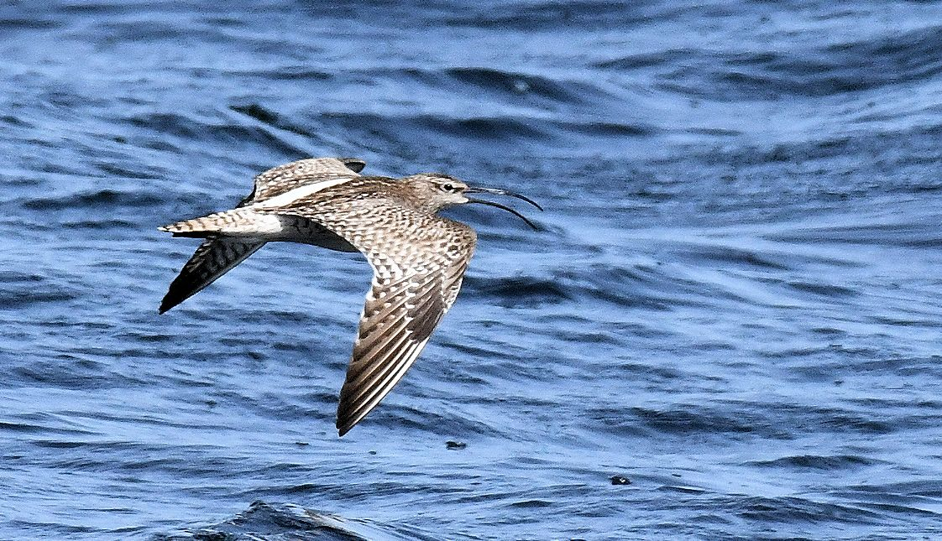
Whimbrel - >N / calling MSBO 28th June
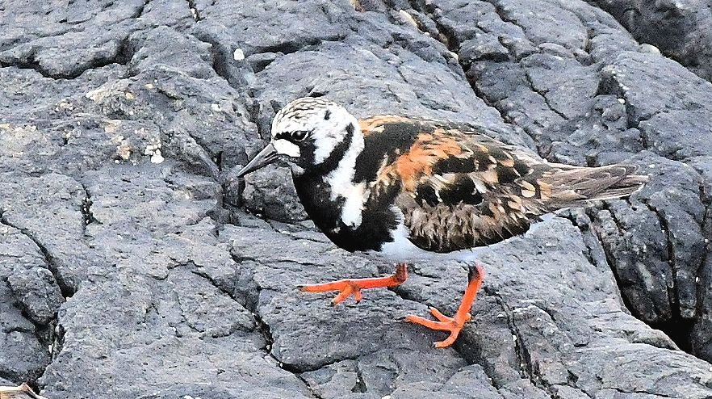
Ruddy Turnstone – MSBO 17th June / rare in summer

Lesser Black-backed Gull
A colour ringed sub-adult was photographed on the point on 23rd (see photo).
It was ringed GV21863 as a chick on Horse Island, off Ardrossan, Ayrshire on 26th June 2017 (Iain Livingstone / Clyde Ringing Group).
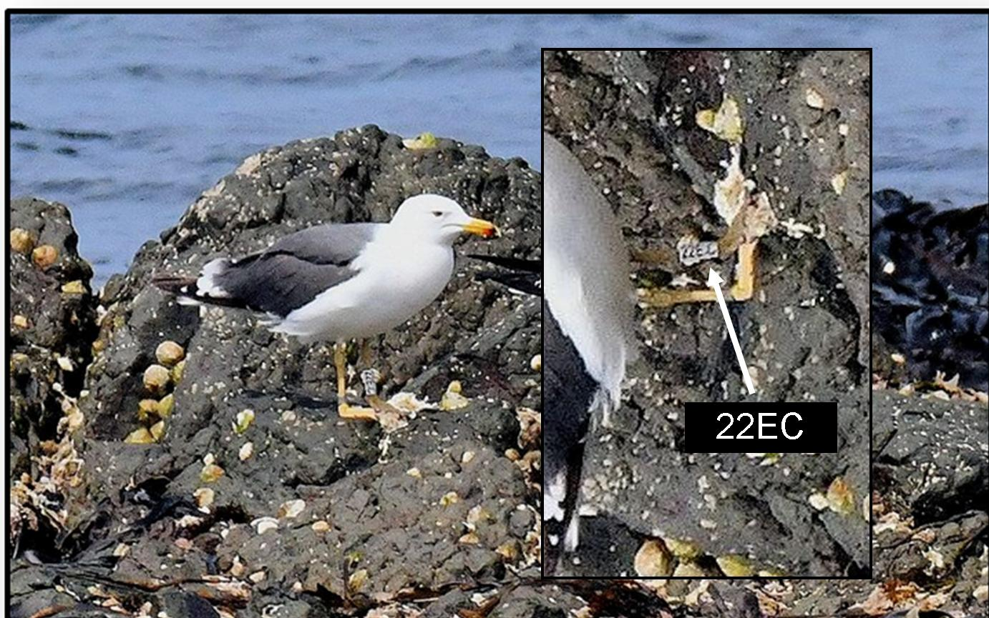
Colour ringed sub-adult Lesser B-b Gull - + alpha / numeric code inset

Sandwich Tern
MSBO / Machrihanish village; 8 on 3rd, 6 on 5th, one on 7th, 2 on 9th, several present daily 15th – 25th, 8 on 26th, one on 27th, 2 on 28th, one on 29th and 5 on 30th.

Arctic Tern
Machrihanish colony; 4 birds ashore on 3rd then none until 5 were displaying over the usual breeding site on 11th; however, not present later. One offshore on 23rd and 2 on 28th.

Northern Wheatear
Breeding; b/4 100m S of MSBO on 6th.
Glenbarr; b/3 Killegruer Camp Site 8th (Pip Ashley pers. comm.).
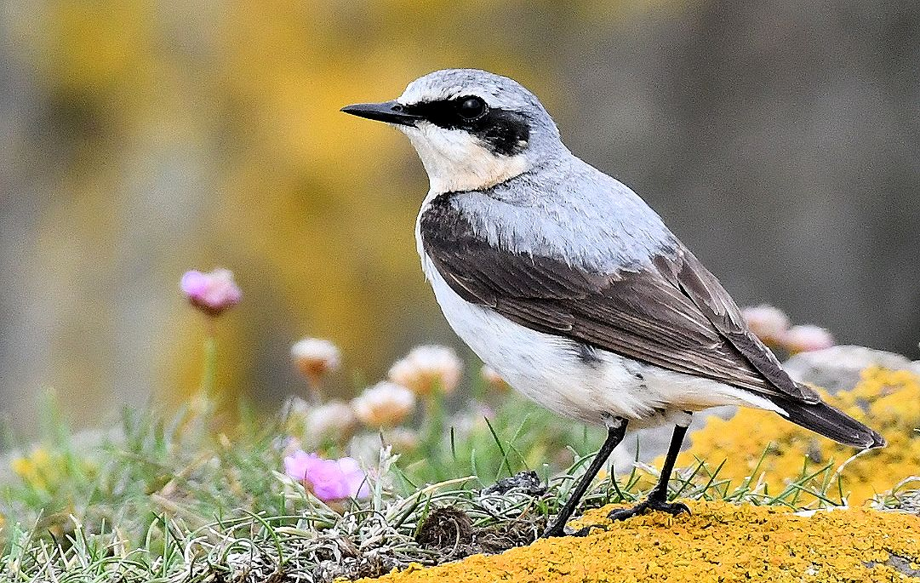
Northern Wheatear – male MSBO 8th June

White Wagtail
Late migrant; one on 1st.

Pied Wagtail
Breeding; 2 pairs bred and fledglings present from 7th.

Rock Pipit
Breeding; 3 pairs bred and by 12th many fledglings were around the point.

Common Starling

Breeding; the number of locally bred juveniles built up all month and peaked at 100+ on 22nd

Common Linnet
Breeding; pair with b/4 present almost daily from 8th (feeding on Thrift seeds).
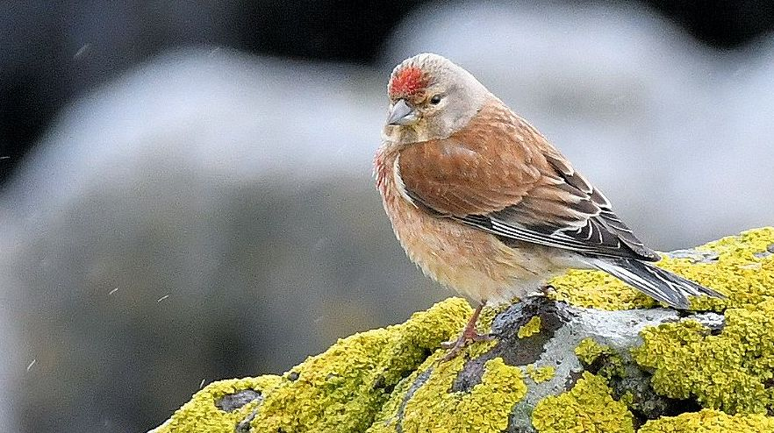
Common Linnet – male MSBO 15th June

Black-headed Bunting
Vagrant.
Isle of Gigha; a male (described well / no photo) at Gigalum (south end of the island) on 8th (Keith Helm per Jim Dickson / County Recorder).

Small Pearl-bordered Fritillary
Tod Hill – SE Kintyre
1st June 2019
By: Jo Goudie
Tod Hill is located by Kildavie Farm about 4km to the NE of Southend village in SE Kintyre, Argyll.
On 1st June 2019 I was surprised to find two Small Pearl-bordered Fritillary Boloria selene there. The first sighting was on the top of Tod Hill at NR723116 where it was observed flying over heather.
The ground on top of the hill (186m ASL) is peat bog and home to plants and flowers necessary for this butterfly’s life cycle. The bog is also a rich breeding ground to many moth species and many were disturbed but it would require further study to ascertain the variety of species present. Easy to spot was the large caterpillar of the Drinker of which several were seen.
The Small Pearl-bordered Fritillary prefers damp, grassy habitat and moorland. It lays eggs on Buttercup, Bugle and Heather, but the main food plant for caterpillars is the Common Dog Violet and Marsh Violet which can be seen on the peaty top of Tod Hill along with Heath Spotted Orchid. After emerging from the pupa, the butterfly will feed on Spear Thistle and Bramble.
The second sighting was lower on the sheltered slope of the hill at NR716118 where the bracken starts to appear again and the ground is less boggy. Here there were thistles in abundance which the butterfly was feeding from and it was then photographed.
The Small Pearl-bordered Fritillary is listed on the Butterfly Conservation Biodiversity List and is classed as status High Priority. Since the 1970’s this species has declined by 34% and sightings have been few in Kintyre.
The areas this butterfly require for its life cycle are rare and becoming rarer due to being planted with alien conifers, damaged by drainage, used as dumps or stripped for garden use. Scottish peat bog areas are under threat, so much so that Butterfly Conservation Scotland has created a Bog Squad Project to ensure these areas are protected and maintained. These areas are increasingly valued for their biodiversity, and the 'ecosystem services' they provide, such as flood prevention and carbon storage. Hopefully, more observation of this area will be possible in the near future.
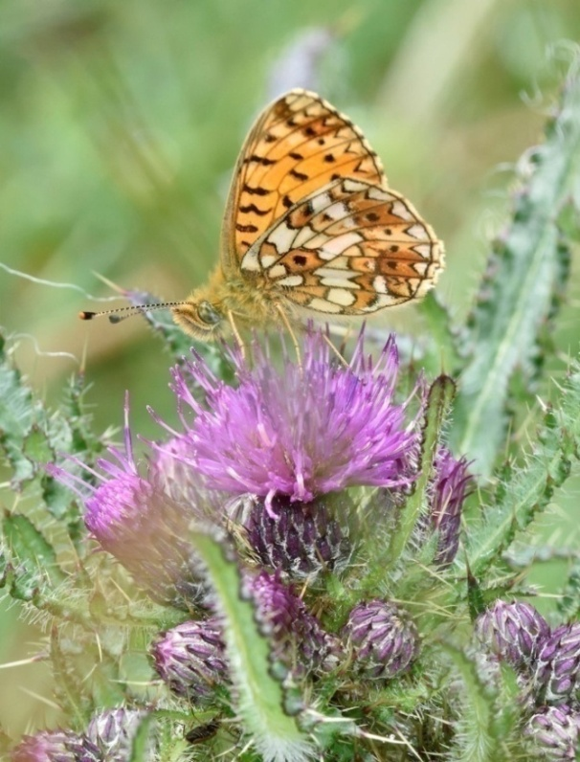
Small Pearl-bordered Fritillary – Tod Hill / by Southend 1st June
Photo / Jo Goudie

Finally - a few more photos taken during June...
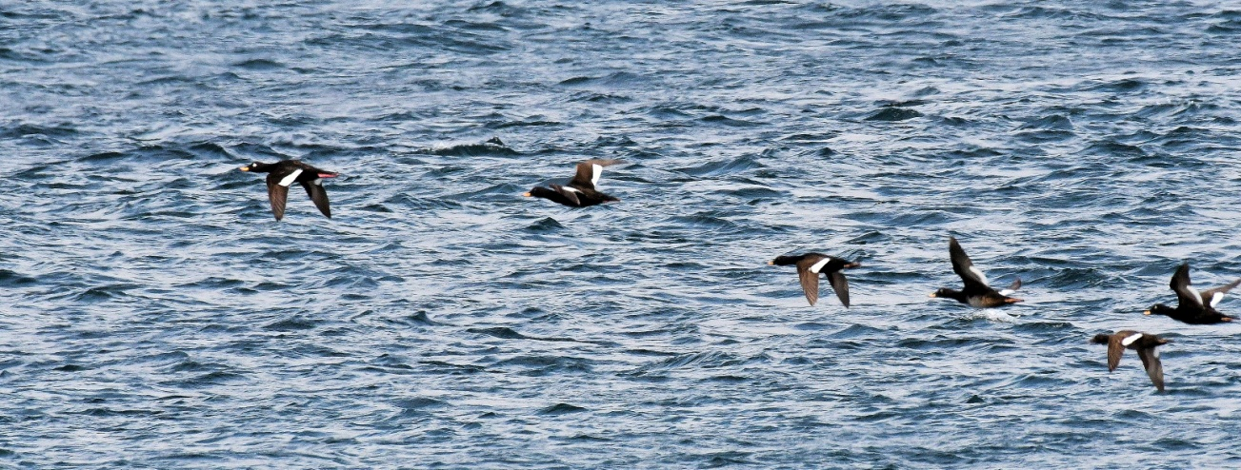
Velvet Scoters - some of the scattered flock (all males) >S on 2nd June

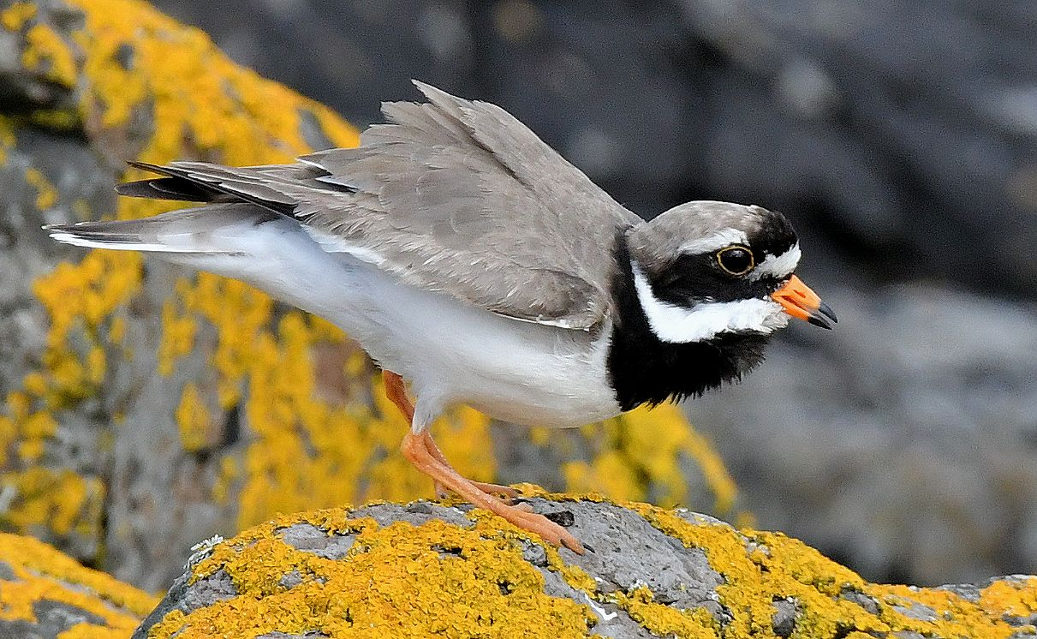
Ringed Plover – male displaying 6th June

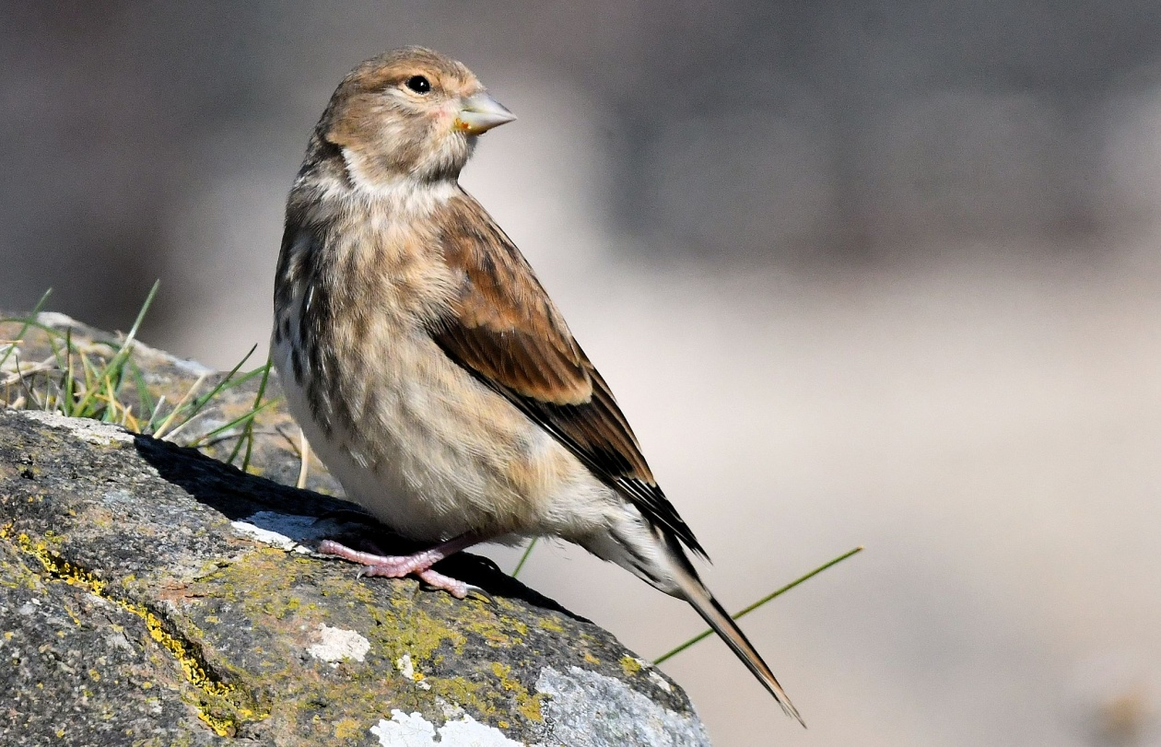
Common Linnet – female MSBO 10th June

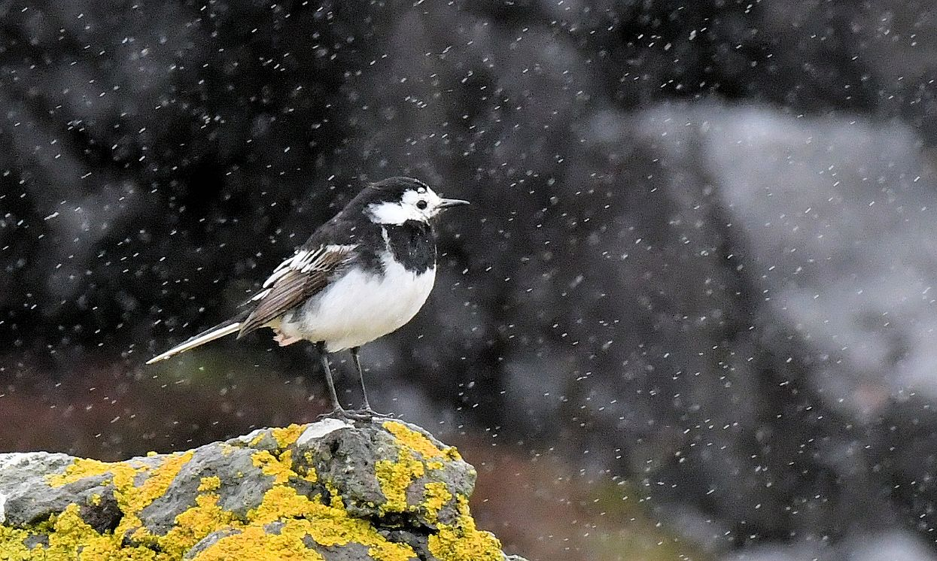
Pied Wagtail – male in the rain MSBO 15th June

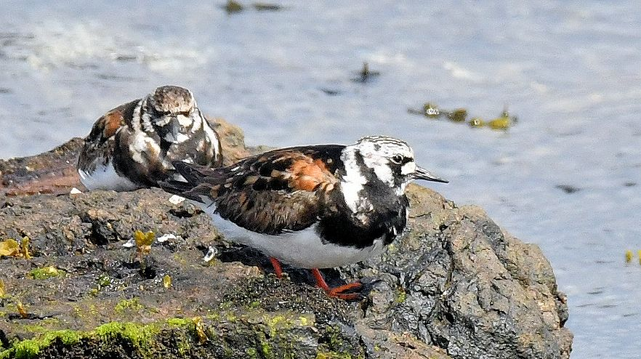
Ruddy Turnstones – 17th June

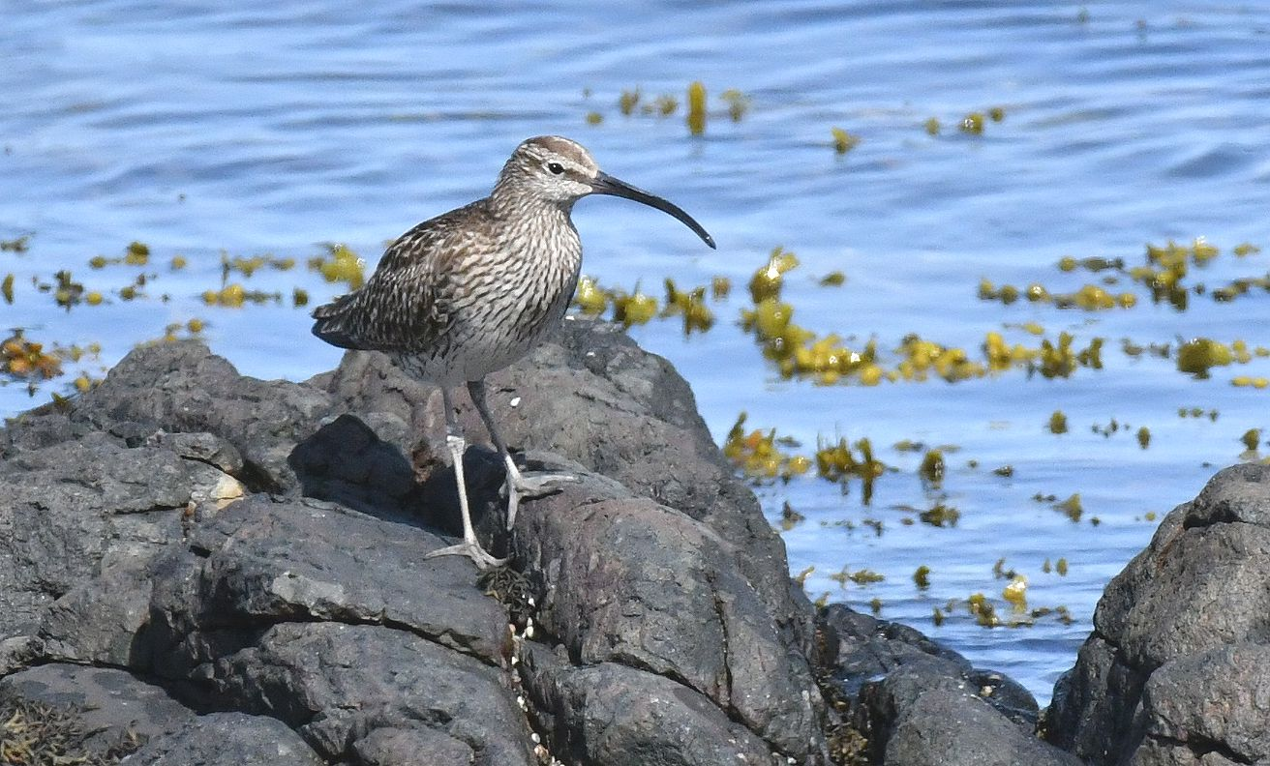
Whimbrel - MSBO 28th June
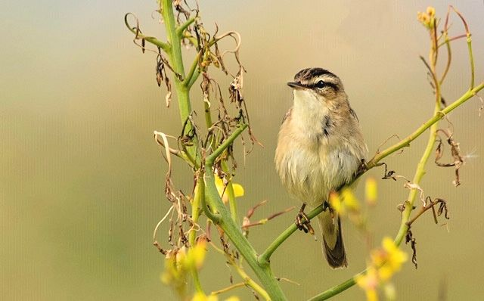
Sedge Warbler – Westport 19th June / photo Cathy Cochrane
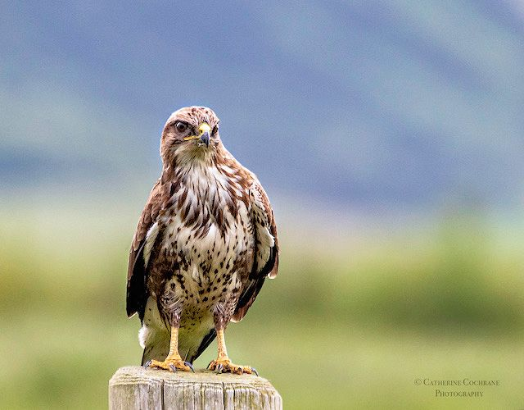
Common Buzzard – Campbeltown Airport / Photo Cathy Cochrane

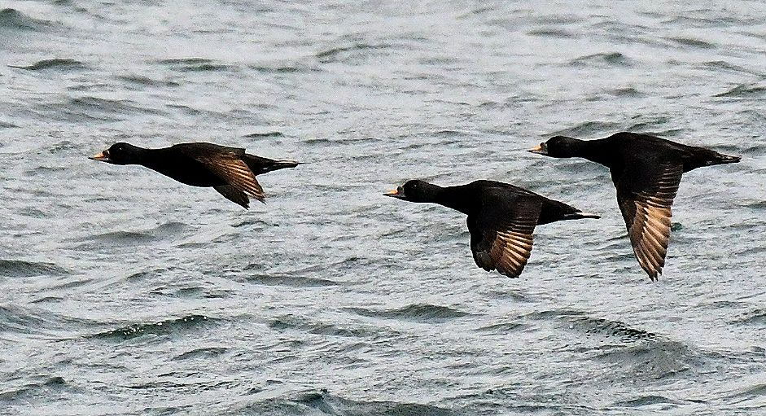
Common Scoters – adult males >S off MSBO 30th June
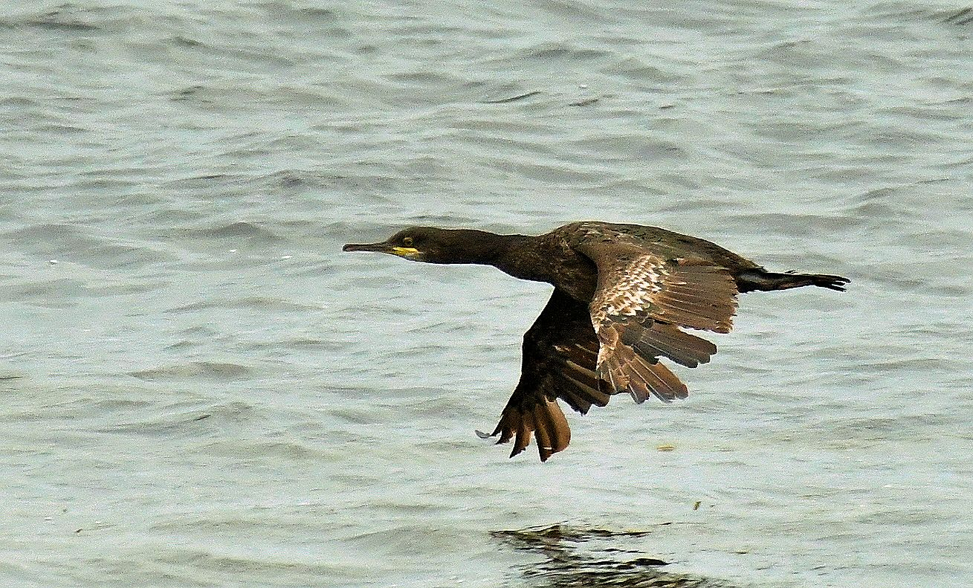
European Shag – a bleached / moulting 2CY off MSBO 30th June

Ends

